# MEETING REPORT No. 01

**Team Name:** *No name for the moment* **Date of Meeting:** 24 March 2020

**Start Time:** 05:45 p.m. **End Time:** 07:45 p.m. **Meeting Location:** Online

**Moderator:** Keli Kasharaj **Recorder:** Enejda Doko

**Other Members Present:** Eni Fejzo, Klintist Dyrmishi, Sardi Shehu

**Members Absent:** None

**Topics Discussed and Decisions Made:**

On the first group meeting held online through Google Meets’ meeting room with Meeting URL: <https://meet.google.com/ywr-wceg-pex> due to the current quarantine state of emergency in Albania, the group got together to discuss and go through all the points in Step One given out. Due to being friends and in the same degree, each one of us had already exchanged their contact information, be it the Epoka e-mail or personal phone number even before the meeting. However, a chat group in Whatsapp was created in order to reach each other easily since it is the most used messaging application by all of us.

Moreover, each team member opened an individual Github accounting as requested and went over practical usages since the group had little knowledge on it. Regarding conflicts, due to the fact that this team has worked together in a previous project which has been finished without complications, we believe that in this project too there will be no problems regarding misunderstandings in project related topics.

Afterwards, it was discussed on deciding the future meeting schedule, by which we did not set a repetitive appointed time. Instead it was decided that a meeting will be held preferable every week on the afternoon of a Tuesday or Wednesday, meaning one or two days before the laboratory hours to better prepare ourselves for them and to allow time to each member to finish their respective assigned tasks. Also the team captain was decided and the roles of each member discussed.

Another important topic to be mention is the proposal of different ideas on existing Albania small and medium enterprises to base this project. Currently the one proposed and most preferred suggestion by the majority is the development of a MIS for Zenith Ltd., a travel agency. It is yet to be set on stone but by the next week, it is believed that we will come to a final decision, if also no other idea is proposed.

**Tasks Assigned:**

Based also on the roles given as an example in the Step one file and the lectures currently gone over by the professor, the roles proposed are as following:

* **One Team Captain (Planning):** responsible to collect, assemble, edit, format and send all the work and project meeting reports to the professor; disseminating the results o the reviews and project feedback to the other members of the team; scheduling team meetings and other relevant activities related to the overview of the project.
* **One Analyst (Modeling):** responsible to collect all the necessary information regarding the client’s business and problem and keeping contact with them; analyze the prevalent problem to be solved and the requirements attached to it such as the product/service’s characteristics and requirements. Basically – defining what the system should do
* **Two Designers (Modeling):** responsible to define the organization of the system and implementing the system. Since we believe the design has a wider variety in its tasks, it was decided more people to be focused on this process’ link.
* **One Programmer (Construction):** responsible to develop and test the product by also offering a practical word to the Designers in order to construct a satisficing product/service.

The roles are mainly taken to fulfill the tasks based on the three of the models’ parts presented in the lectures, namely Planning, Modeling and Constructing. They might be worked over once again based on the business solution the project will implement; however until now this will be the official chart.

**Time, Place, and Agenda for Next Meeting:**

The time and place will probably be the same, meaning online with camera and speaker on the Google meet platform starting around 5:30 to 6:00 p.m. on the upcoming Tuesday or Wednesday. The agenda will be going over the Step two, deciding on the Team name, project mission and objectives regarding the business solution, final team roles and begging of the actual project work by handing out the respective tasks to each team member.

**ANNEX ONE:** Photos of the First Meeting

**Start of Meeting**

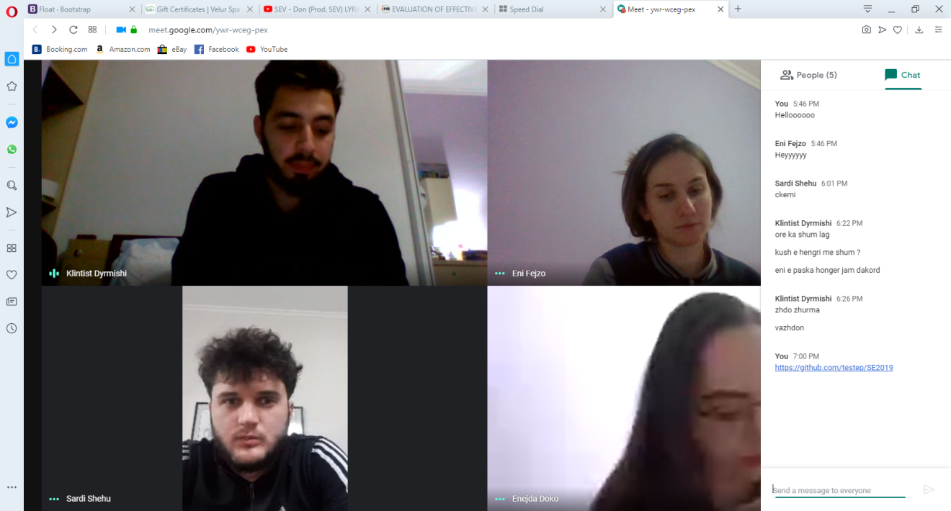

**During the Meeting**

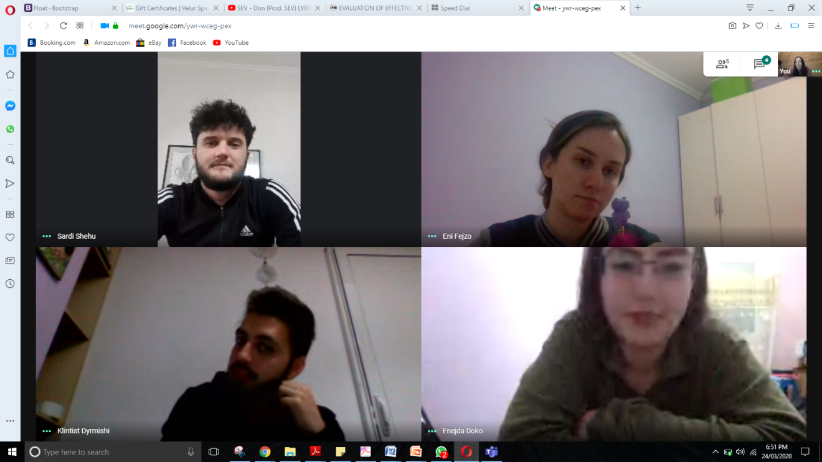

**End of Meeting**

